1. **REGISTERATION:**

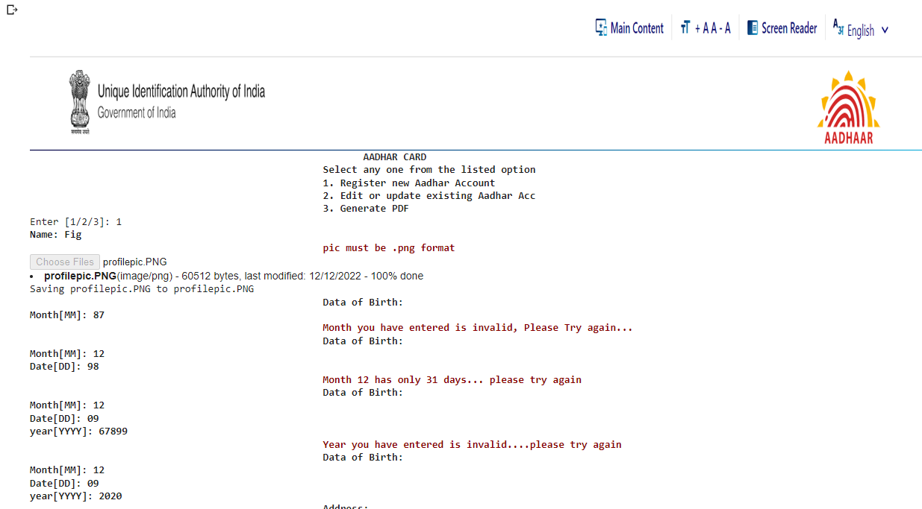

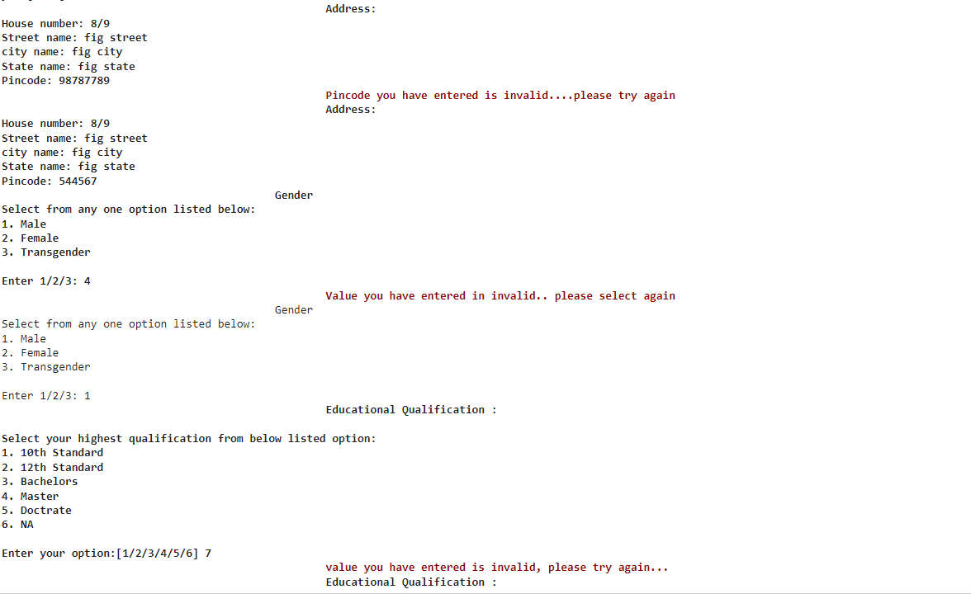

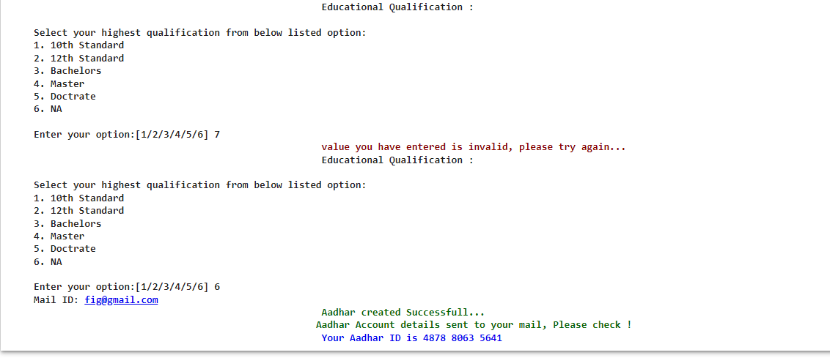

**MAIL:**

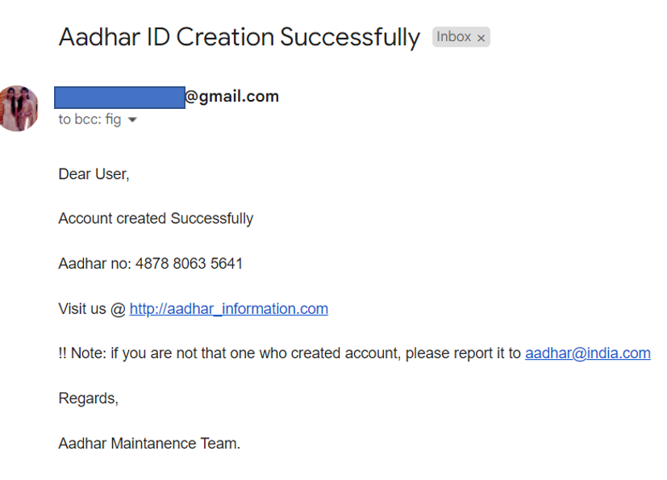

1. **UPDATE:**

**CASE 1: UNSUCCESSFULL IN UPDATE: WRONG OTP**

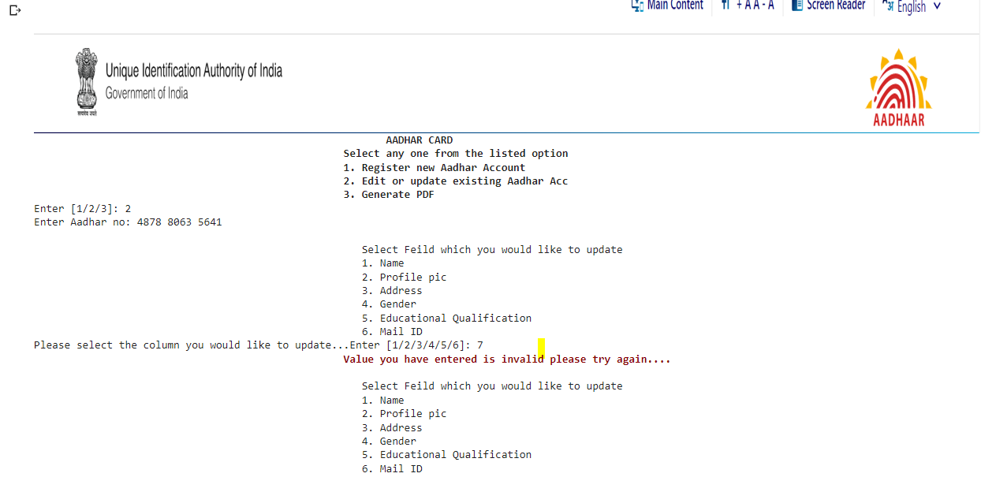

**Getting Aadhar no to Edit**

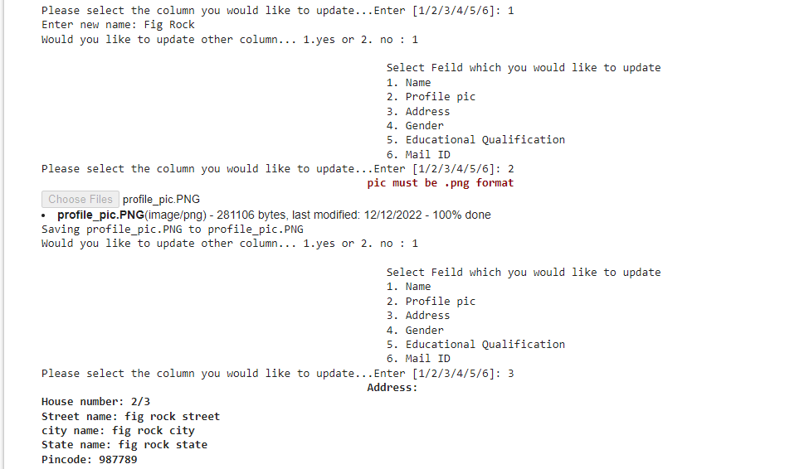

**UPDATING ADDRESS**

**UPDATING PROFILE PIC**

**UPDATING NAME**

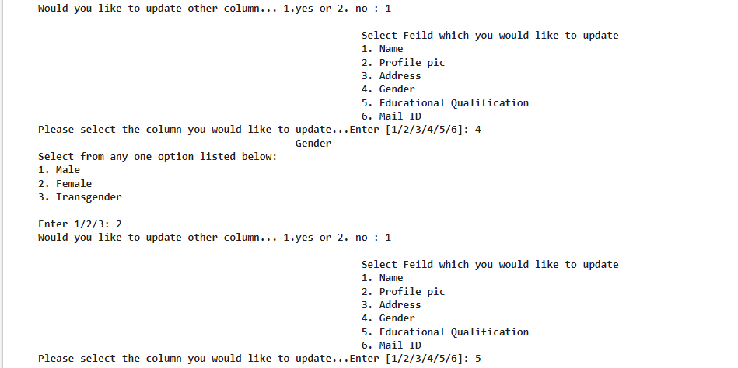

EDUCATION UPDATE

GENDER UPDATE

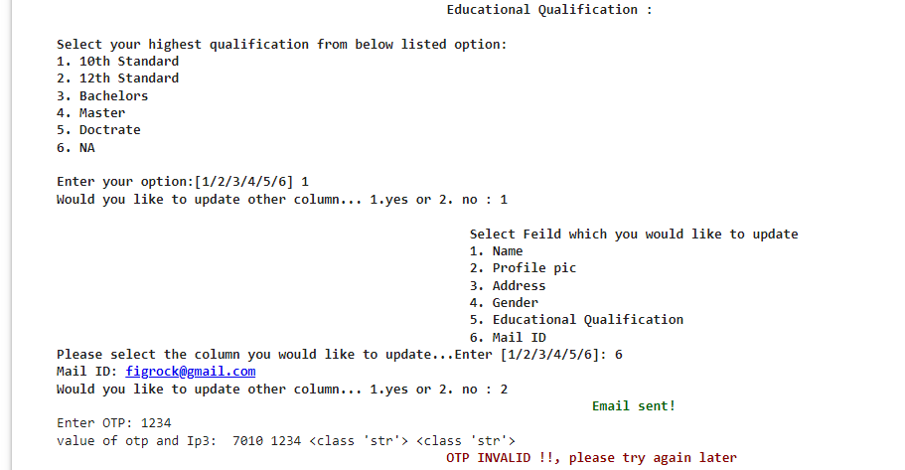



OTP VALIDATION

MAIL UPDATE

**MAIL:**

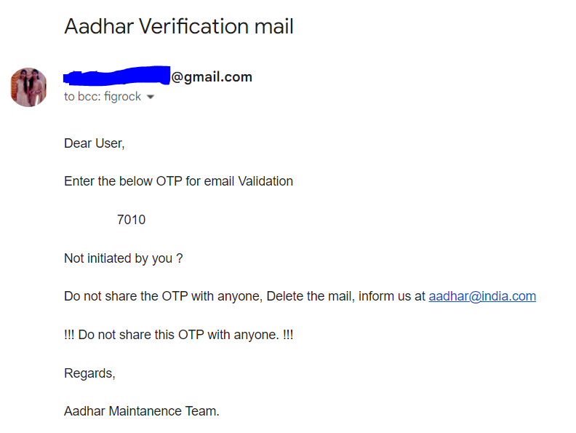

**PDF:**

**DETAILS NOT UPDATED:**

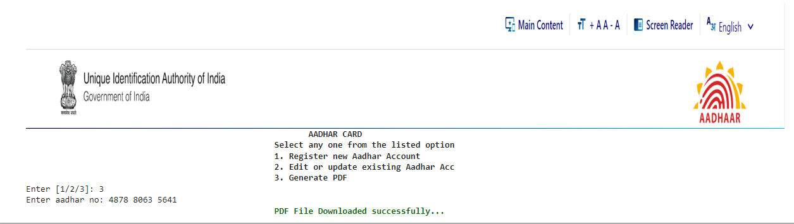

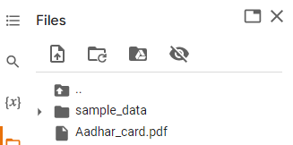

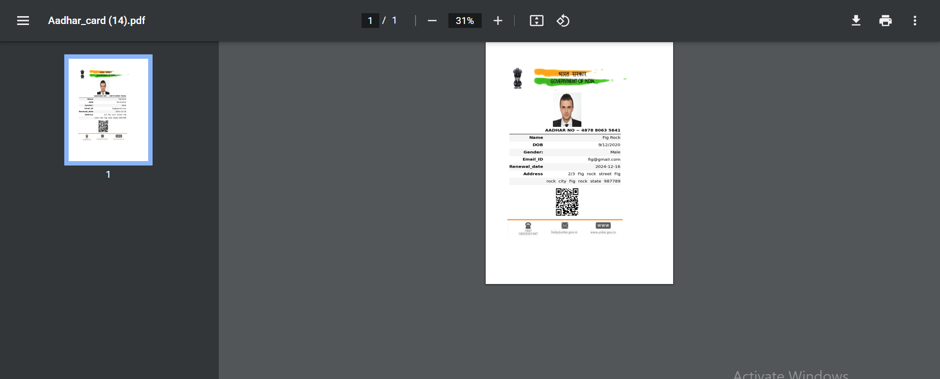

**DB:**

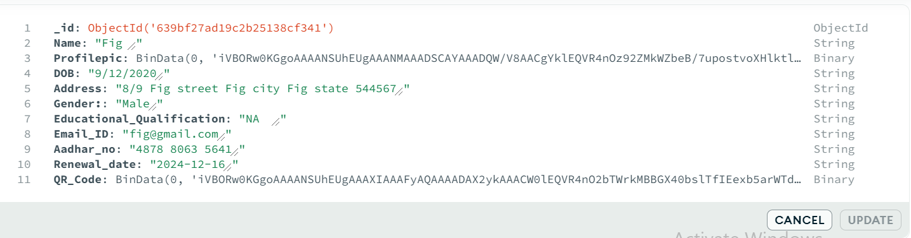

**CASE 2: OTP CORRECT VALUE**



**UPDATED IN DB AND PDF…**

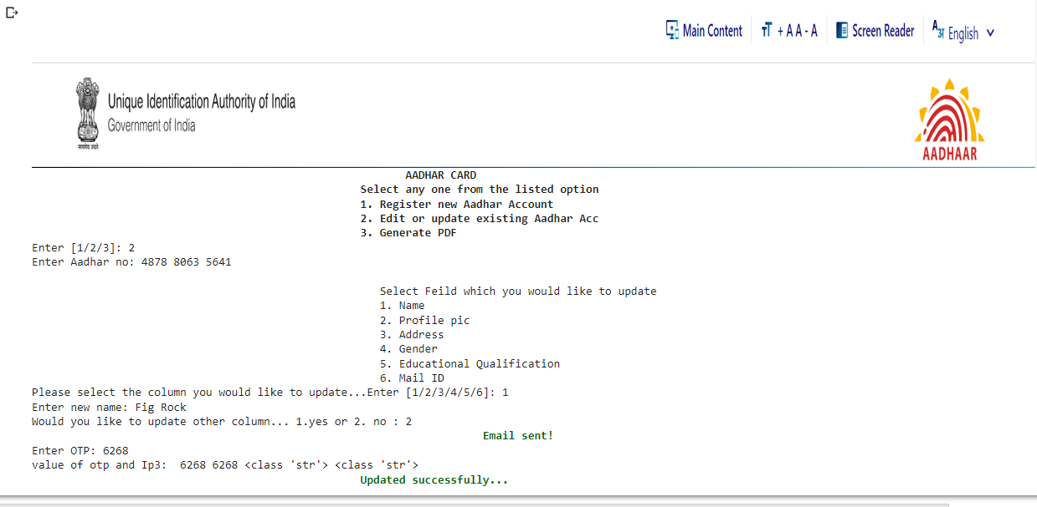



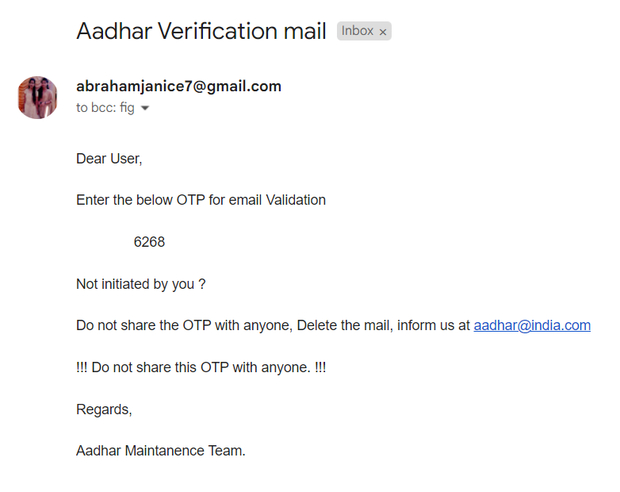

**PDF:**

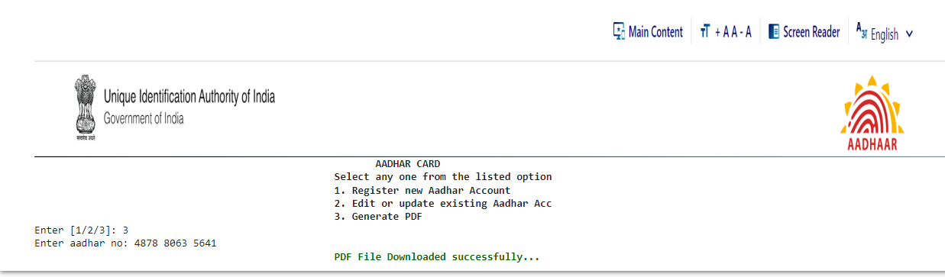

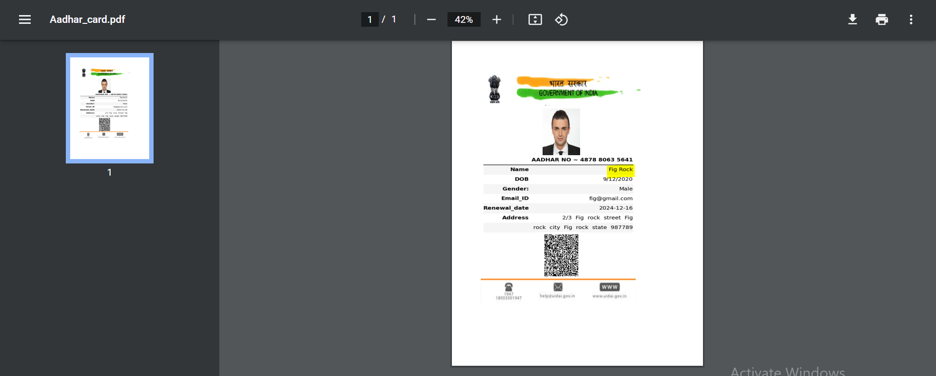

**CASE 3:**

**RENEWAL DATE:**

**For Fig rock 🡪 renewal date is 2024**

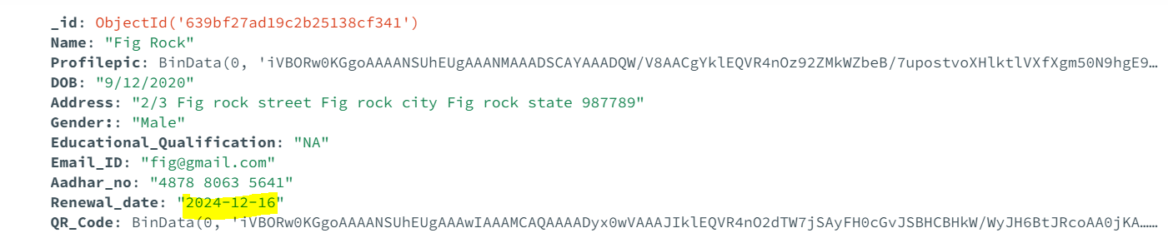

**User can only update two years once…**

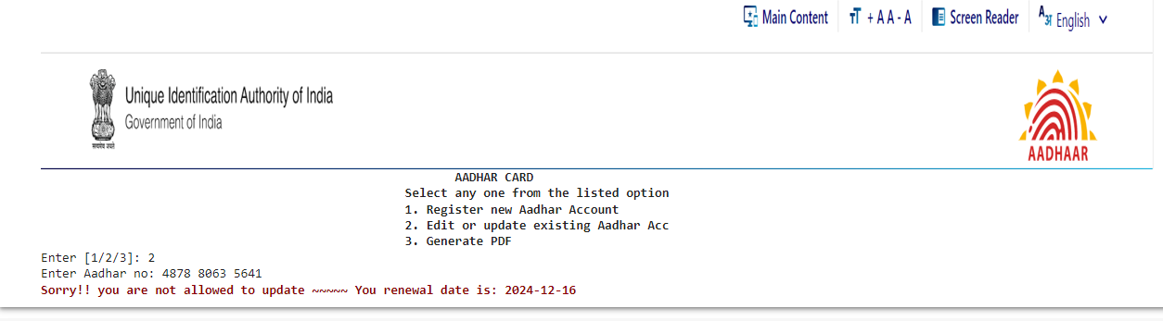

**CASE 4: TRYING TO UPDATE ACC WHICH IS NOT YET CREATED….**

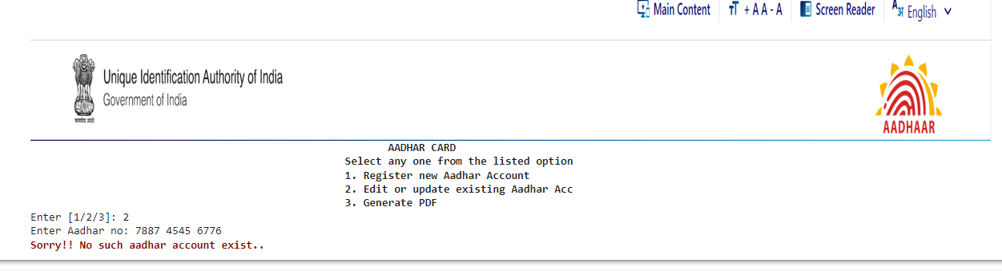

**PDF UNSUCCESSFULL:**

